Do-it-yourself ADC
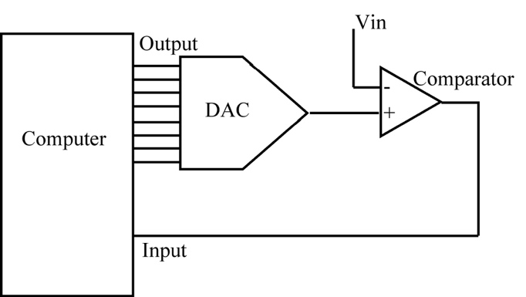
As you learned in chapter 27, a successive approximation analog-to-digital converter consists of a DAC and a comparator controlled by a computer (see outline figure, left).
The computer compares the input voltage, Vin, to the voltage produced by the DAC and uses the ‘closest’ value as the analog conversion.

Task 1: The DAC
The first task is to get the DAC working again. You should verify (with the sawtooth program) that it still works.

Task 2: The Comparator
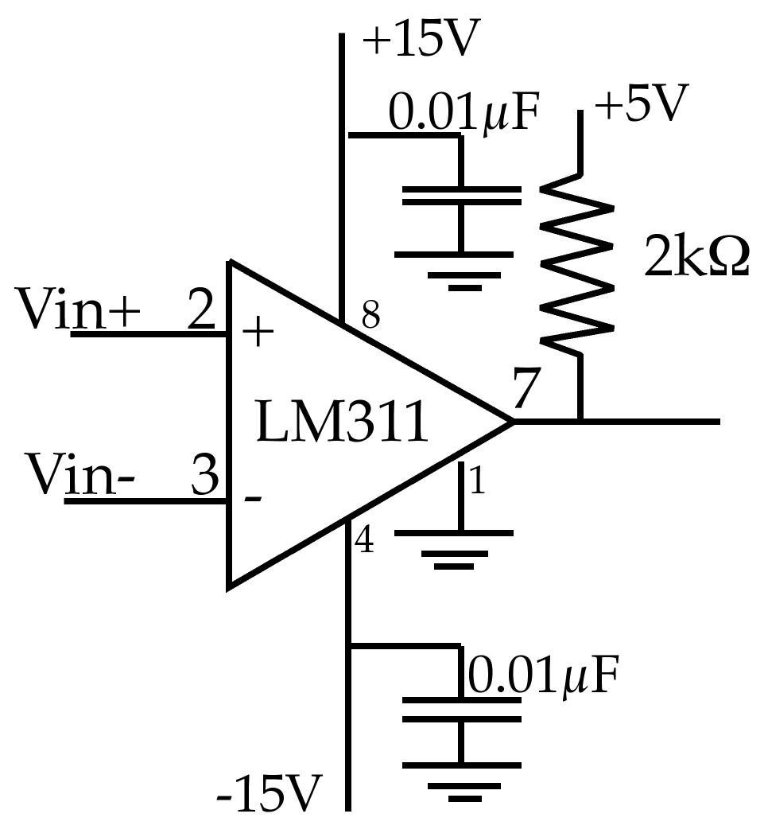
Now you need to build a comparator. For this we will use an LM311 comparator. This is a single package with both an op-amp and an output transistor. It is designed so that the input voltages can range over the full analog power supply range while the output can be a standard 0-5V logic signal. It is described in a little more detail in section 23.2 in the Electronics book, which you should go read NOW!
Note that the pinout is NEARLY that of an op-amp but NOT QUITE!
Build the circuit (figure, left) on the same board as the DAC and computer. Connect pin 2 of the LM311 to +5V and pin 3 to the center tap on a 10k variable resistor connected to a 10k resistor between ground and +15V (see below left).

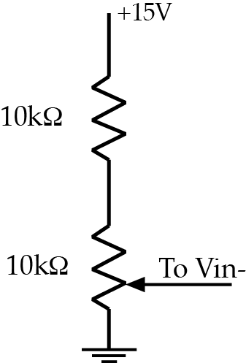

a) Plot Vout as a function of the voltage on pin 3 and paste your plot below.

b) Explain your graph.

Task 3: The first connection
Now disconnect pin 2 of the comparator from 5V and connect it to the output of your DAC. Set the voltage from the variable resistor to a value near 5V.
a) Display the DAC voltage and the output of the comparator on the scope and run your ramp program. Paste your plot below.

b) Explain your plot.

c) Describe and explain what happens if you change the input voltage.

Task 4: Completing the loop
Now connect the comparator output back to an input pin of your Feather and modify your ramp program so that it goes through the numbers until the input from the comparator changes and then prints the stopping number. The program should run in an infinite loop so that the number on the screen changes as you alter the input voltage.
Record some input voltages as measured on your DVM and their equivalents as found by the computer.
a) Plot the DVM voltages against the numeric values and see if you get a straight line. Paste the plot below.

b) Describe the resulting plot and discuss any deviations from theory that you find.

c) Deduce a formula to convert the numeric value that your program finds to an actual voltage.

